**WEB PROGRAMMING PROJECT**

### Project Infomation

Project Name: VaniBao Bookstore

Author: Qingjun Bao

Last Update Date: 2022-08-19

Develop language: html CSS PHP

Develop IDE: VS Code

### Website Design Purpose

Create an online bookstore where readers and Vanier College students can purchase a variety of paper books, teaching materials, extracurricular interest books, and online e-books.

And provide online bookstore management functions.

**Database Design Purpose**

**vb_users** is the user table, who browser log records in **vb_browse_log** table, **vb_orders** references user’s idfrom **vb_users** andaddress idfrom **vb_address, vb_order_book** table builds relationship between **vb_orders** and **vb_books** with order_id from **vb_orders** andbook_id from **vb_books. Then vb_books** table store all the detail of books which references from **vb_category, vb_auther** and **vb_publisher**.

**Database Tables Imported in phpMyAdmin**

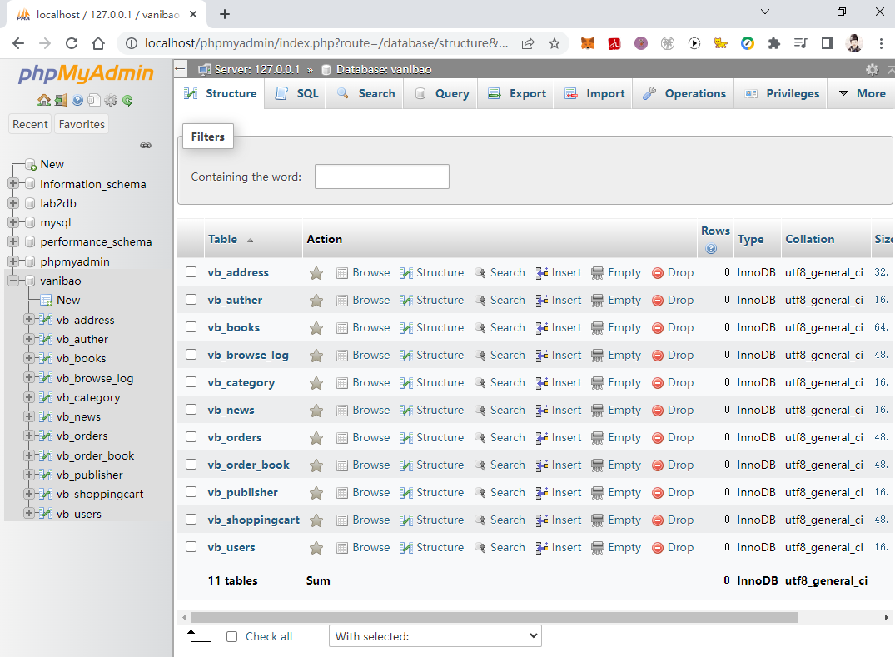

**Database ER Diagram**

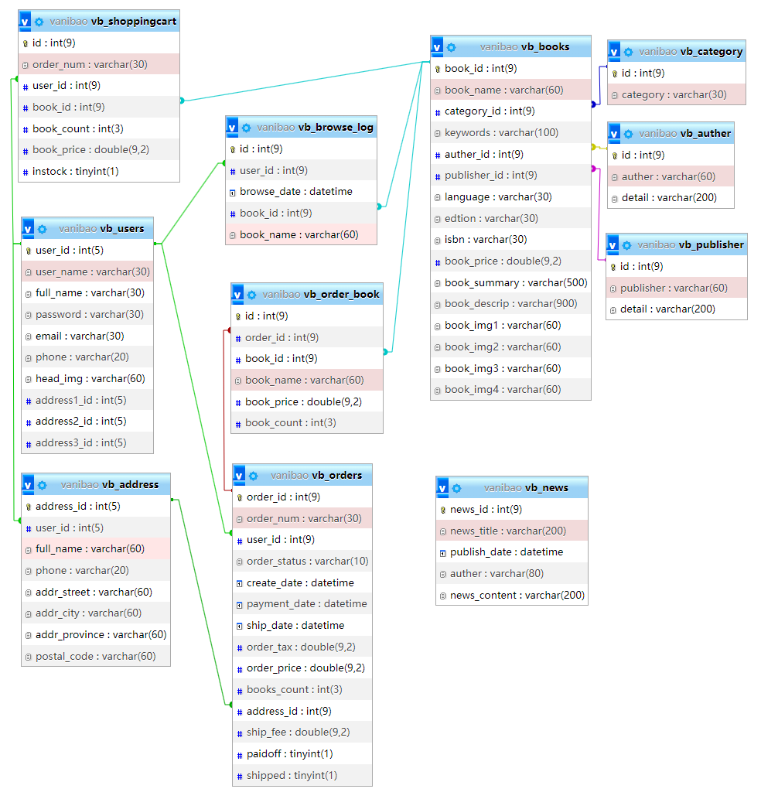

**Database Schema Design**

* User Table : vb_users

|  |  |  |  |
| --- | --- | --- | --- |
| **Field Name** | **Type** | **Constraint** | **Description** |
| user_id | INT | PK | Primary Key |
| user_name | VARCHAR(60) |  | login name |
| full_name | VARCHAR(60) |  | nick name |
| password | VARCHAR(80) | NOT NULL | password char |
| email | VARCHAR(80) |  | email address |
| phone | VARCHAR(20) |  | phone number |
| head_img | VARCHAR(60) |  | head image |
| address1_id | INT |  | user's address 1 |
| address2_id | INT |  | user's address 2 |
| address3_id | INT |  | user's address 3 |

* Book Table : vb_books

|  |  |  |  |
| --- | --- | --- | --- |
| **Field Name** | **Type** | **Constraint** | **Description** |
| book_id | INT | PK | Primary Key |
| book_name | VARCHAR(60) |  | book's name |
| category_id | INT | FK | category ID |
| keywords | VARCHAR(100) |  | keywords |
| auther_id | INT | FK | auther ID |
| publisher_id | INT | FK | publisher ID |
| language | VARCHAR(30) |  | language |
| edtion | VARCHAR(30) |  | edtion |
| isbn | VARCHAR(30) |  | ISBN |
| book_price | DOUBLE(9,2) |  | book's price |
| book_summary | VARCHAR(500) |  | summary |
| book_descrip | VARCHAR(900) |  | description |
| book_img | VARCHAR(60) |  | book's image |

* Address Table : vb_address

|  |  |  |  |
| --- | --- | --- | --- |
| **Field Name** | **Type** | **Constraint** | **Description** |
| address_id | INT | PK | Primary Key |
| user_id | INT | FK | user's ID |
| full_name | VARCHAR(60) |  | postal name |
| phone | VARCHAR(20) |  | phone number |
| addr_street | VARCHAR(60) |  | postal street |
| addr_city | VARCHAR(20) |  | postal city |
| addr_province | VARCHAR(20) |  | postal province |
| postal_code | VARCHAR(10) |  | postal code |

* Order Table : vb_orders

|  |  |  |  |
| --- | --- | --- | --- |
| **Field Name** | **Type** | **Constraint** | **Description** |
| order_id | INT | PK | Primary Key |
| order_num | VARCHAR(60) | NOT NULL | order number |
| user_id | INT | FK | order user ID |
| order_status | VARCHAR(10) |  | order's status |
| create_date | DATETIME |  | create time |
| payment_date | DATETIME |  | payment time |
| ship_date | DATETIME |  | delivery time |
| order_tax | DOUBLE(9,2) |  | order taxes |
| order_price | DOUBLE(9,2) |  | order sum price |
| books_count | INT |  | how many books |
| address_id | INT | FK | order address |
| ship_fee | DOUBLE(9,2) |  | ship fee |
| paidoff | BOOLEAN |  | paid off or not |
| shipped | BOOLEAN |  | shipped or not |

* Ordered Books : vb_order_book

|  |  |  |  |
| --- | --- | --- | --- |
| **Field Name** | **Type** | **Constraint** | **Description** |
| id | INT | PK | Primary Key |
| order_id | INT | FK | Order ID |
| book_id | INT | FK | book's ID |
| book_name | VARCHAR(60) |  | book's name |
| book_price | DOUBLE(9,2) |  | book's price |
| book_count | INT |  | books amount |

* Shopping Cart : vb_shoppingcart

|  |  |  |  |
| --- | --- | --- | --- |
| **Field Name** | **Type** | **Constraint** | **Description** |
| id | INT | PK | Primary Key |
| order_num | VARCHAR(30) | FK | order number |
| user_id | INT | FK | user's ID |
| book_id | INT | FK | book's ID |
| book_count | INT |  | books amount |
| book_price | DOUBLE(9,2) |  | book price |
| instock | BOOLEAN |  | available or not |

* vb_browse_log

|  |  |  |  |
| --- | --- | --- | --- |
| **Field Name** | **Type** | **Constraint** | **Description** |
| id | INT | PK | Primary Key |
| user_id | INT | FK | user's ID |
| browse_date | DATETIME |  | browse time |
| book_id | INT | FK | book's ID |
| book_name | VARCHAR(60) |  | book's name |

* vb_category

|  |  |  |  |
| --- | --- | --- | --- |
| **Field Name** | **Type** | **Constraint** | **Description** |
| id | INT | PK | Primary Key |
| category | VARCHAR(30) |  | category |

* vb_auther

|  |  |  |  |
| --- | --- | --- | --- |
| **Field Name** | **Type** | **Constraint** | **Description** |
| id | INT | PK | Primary Key |
| auther | VARCHAR(60) |  | auther name |
| detail | VARCHAR(200) |  | auther detail |

* vb_publisher

|  |  |  |  |
| --- | --- | --- | --- |
| **Field Name** | **Type** | **Constraint** | **Description** |
| id | INT | PK | Primary Key |
| publisher | VARCHAR(60) |  | publisher name |
| detail | VARCHAR(200) |  | publisher detail |

* vb_news

|  |  |  |  |
| --- | --- | --- | --- |
| **Field Name** | **Type** | **Constraint** | **Description** |
| news_id | INT | PK | Primary Key |
| news_title | VARCHAR(200) |  | news title |
| publish_date | DATETIME |  | publish time |
| auther | VARCHAR(80) |  | auther |
| news_content | VARCHAR(200) |  | news title |

**Database SQL statement**

1. **DROP** **DATABASE** IF EXISTS `vanibao`;
3. **CREATE** **DATABASE** IF NOT EXISTS vanibao **DEFAULT** **CHARACTER** **SET** utf8 **COLLATE** utf8_general_ci;
4. USE `vanibao`;
5. **SET** FOREIGN_KEY_CHECKS = 0;
7. **DROP** **TABLE** IF EXISTS vb_users;
8. **DROP** **TABLE** IF EXISTS vb_books;
9. **DROP** **TABLE** IF EXISTS vb_address;
10. **DROP** **TABLE** IF EXISTS vb_orders;
11. **DROP** **TABLE** IF EXISTS vb_order_book;
12. **DROP** **TABLE** IF EXISTS vb_shoppingcart;
13. **DROP** **TABLE** IF EXISTS vb_browse_log;
14. **DROP** **TABLE** IF EXISTS vb_category;
15. **DROP** **TABLE** IF EXISTS vb_news;

18. **CREATE** **TABLE** vb_users (
19. user_id **INT**(9) **PRIMARY** **KEY** AUTO_INCREMENT,
20. user_name **VARCHAR**(30),
21. full_name **VARCHAR**(30),
22. **password** **VARCHAR**(30),
23. email **VARCHAR**(30),
24. phone **VARCHAR**(20),
25. head_img **VARCHAR**(60),
26. address1_id **INT**(9),
27. address2_id **INT**(9),
28. address3_id **INT**(9));
30. **CREATE** **TABLE** vb_address (
31. address_id **INT**(9) **PRIMARY** **KEY** AUTO_INCREMENT,
32. user_id **INT**(9),
33. full_name **VARCHAR**(60),
34. phone **VARCHAR**(20),
35. addr_street **VARCHAR**(60),
36. addr_city **VARCHAR**(60),
37. addr_province **VARCHAR**(60),
38. postal_code **VARCHAR**(60),
39. **FOREIGN** **KEY** (user_id) **REFERENCES** vb_users(user_id));
41. **CREATE** **TABLE** vb_category (
42. id **INT**(9) **PRIMARY** **KEY** AUTO_INCREMENT,
43. category **VARCHAR**(30));
45. **CREATE** **TABLE** vb_auther (
46. id **INT**(9) **PRIMARY** **KEY** AUTO_INCREMENT,
47. auther **VARCHAR**(60),
48. detail **VARCHAR**(200));
50. **CREATE** **TABLE** vb_publisher (
51. id **INT**(9) **PRIMARY** **KEY** AUTO_INCREMENT,
52. publisher **VARCHAR**(60),
53. detail **VARCHAR**(200));
55. **CREATE** **TABLE** vb_books (
56. book_id **INT**(9) **PRIMARY** **KEY** AUTO_INCREMENT,
57. book_name **VARCHAR**(60),
58. category_id **INT**(9),
59. keywords **VARCHAR**(100),
60. auther_id **INT**(9),
61. publisher_id **INT**(9),
62. language **VARCHAR**(30),
63. edtion **VARCHAR**(30),
64. isbn **VARCHAR**(30),
65. book_price **DOUBLE**(9,2),
66. book_summary **VARCHAR**(500),
67. book_descrip **VARCHAR**(900),
68. book_img1 **VARCHAR**(60),
69. book_img2 **VARCHAR**(60),
70. book_img3 **VARCHAR**(60),
71. book_img4 **VARCHAR**(60),
72. **FOREIGN** **KEY** (category_id) **REFERENCES** vb_category(id),
73. **FOREIGN** **KEY** (auther_id) **REFERENCES** vb_auther(id),
74. **FOREIGN** **KEY** (publisher_id) **REFERENCES** vb_publisher(id));
76. **CREATE** **TABLE** vb_orders (
77. order_id **INT**(9) **PRIMARY** **KEY** AUTO_INCREMENT,
78. order_num **VARCHAR**(30),
79. user_id **INT**(9),
80. order_status **VARCHAR**(10),
81. create_date DATETIME,
82. payment_date DATETIME,
83. ship_date DATETIME,
84. order_tax **DOUBLE**(9,2),
85. order_price **DOUBLE**(9,2),
86. books_count **INT**(3),
87. address_id **INT**(9),
88. ship_fee **DOUBLE**(9,2),
89. paidoff BOOLEAN,
90. shipped BOOLEAN,
91. **FOREIGN** **KEY** (user_id) **REFERENCES** vb_users(user_id),
92. **FOREIGN** **KEY** (address_id) **REFERENCES** vb_address(address_id));
94. **CREATE** **TABLE** vb_order_book (
95. id **INT**(9) **PRIMARY** **KEY** AUTO_INCREMENT,
96. order_id **INT**(9),
97. book_id **INT**(9),
98. book_name **VARCHAR**(60),
99. book_price **DOUBLE**(9,2),
100. book_count **INT**(3),
101. **FOREIGN** **KEY** (order_id) **REFERENCES** vb_orders(order_id),
102. **FOREIGN** **KEY** (book_id) **REFERENCES** vb_books(book_id));
104. **CREATE** **TABLE** vb_shoppingcart (
105. id **INT**(9) **PRIMARY** **KEY** AUTO_INCREMENT,
106. order_num **VARCHAR**(30),
107. user_id **INT**(9),
108. book_id **INT**(9),
109. book_count **INT**(3),
110. book_price **DOUBLE**(9,2),
111. instock BOOLEAN,
112. **FOREIGN** **KEY** (user_id) **REFERENCES** vb_users(user_id),
113. **FOREIGN** **KEY** (book_id) **REFERENCES** vb_books(book_id));
115. **CREATE** **TABLE** vb_browse_log (
116. id **INT**(9) **PRIMARY** **KEY** AUTO_INCREMENT,
117. user_id **INT**(9),
118. browse_date DATETIME,
119. book_id **INT**(9),
120. book_name **VARCHAR**(60),
121. **FOREIGN** **KEY** (user_id) **REFERENCES** vb_users(user_id),
122. **FOREIGN** **KEY** (book_id) **REFERENCES** vb_books(book_id));

125. **CREATE** **TABLE** vb_news (
126. news_id **INT**(9) **PRIMARY** **KEY** AUTO_INCREMENT,
127. news_title **VARCHAR**(200),
128. publish_date  DATETIME,
129. auther **VARCHAR**(80),
130. news_content **VARCHAR**(200));

**VaniBao Bookstore Project link:**

https://github.com/polluxbao/vanibao-bookstore